CN7031 - Big Data Analytics
Student ID: 3059676
Name: Mann Shrestha

Lab-4

Exercise 1: Getting Ready for Hue Cloudera
Exercise 2: Create Database/Table
Step 1: Create a database and table
- “userdb6” Database were created.
- Empty table named “employee” were created with setting up the delimiter field terminated by “\t” and line terminated by “\n”.
Step 2: Load Data
- Loading data named Simple.txt from Cloudera desktop.
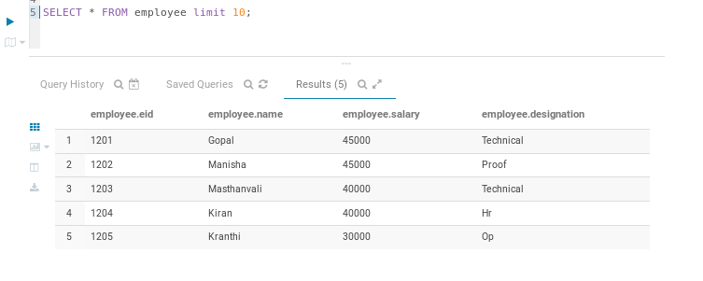
- Adding “dept” column in an employee table using ALTER statement.
Exercise 3: Working with Hive queries
Step 1: Retrieving information
- WHERE query
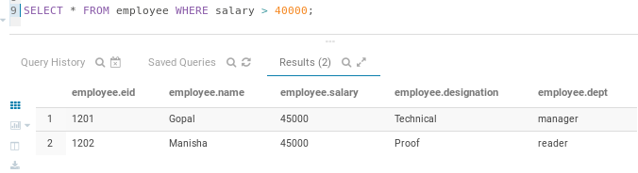

- Order By query
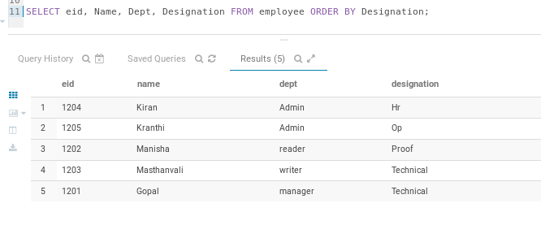
- Group By query
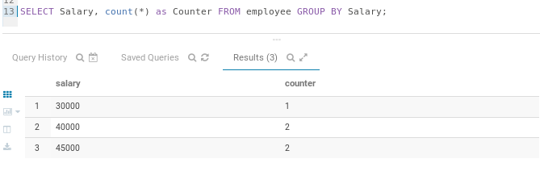
Step 2: Create a view
- Creating a view – virtual table
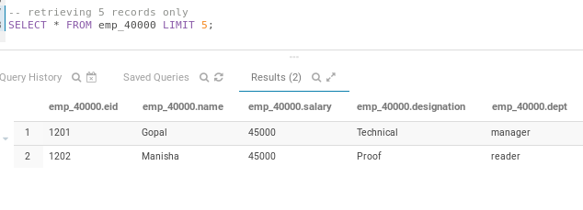
Step 3: Join queries
- Joining two tables’ Customers and Orders table.
- Creating Customers table
- Load the Customers.txt data from Cloudera home
- List 10 records from Customers table.
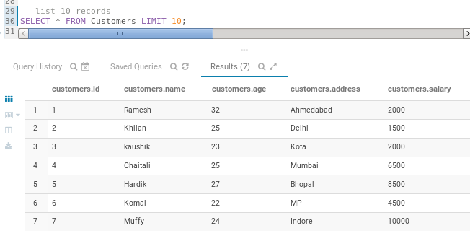
- Create a table for Orders
- Load the Orders.txt data from Cloudera home
- List the data
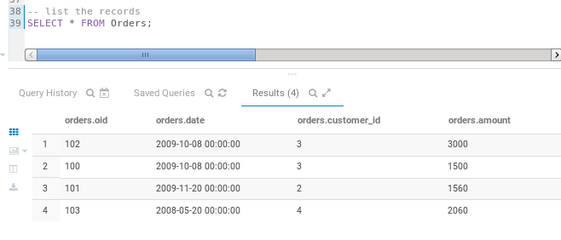
- Joining a tables Customers and Orders
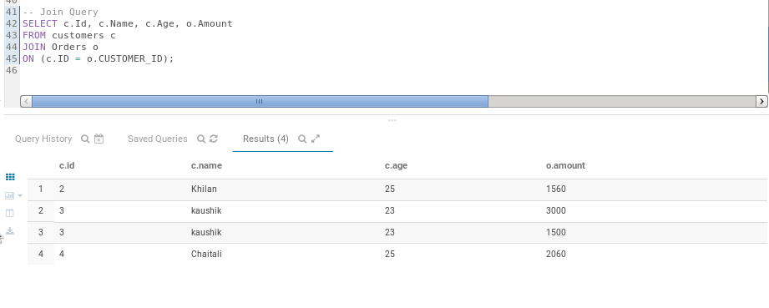
- Making a LEFT OUTER JOIN between CUSTOMER and ORDER tables
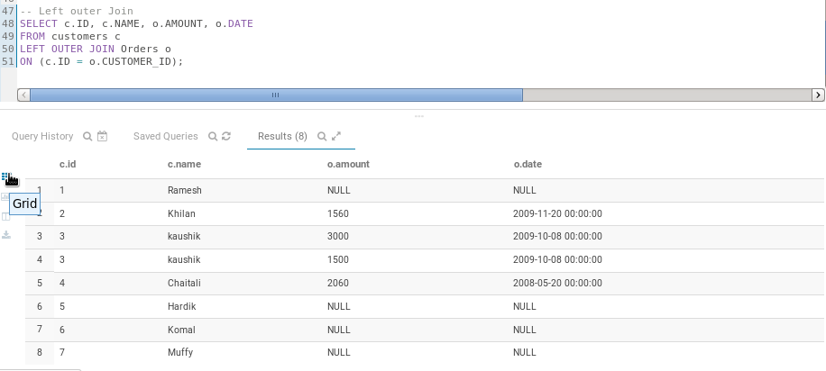

- Making a RIGHT OUTER JOIN between CUSTOMER and ORDER tables
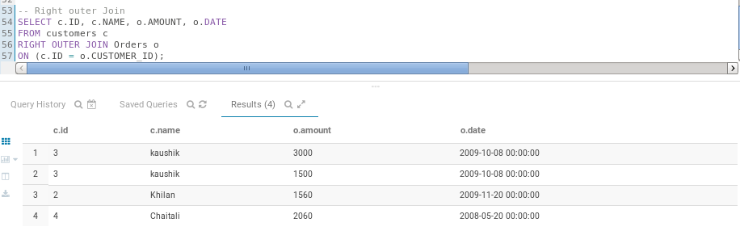
- Making a FULL OUTER JOIN between CUSTOMER and ORDER tables
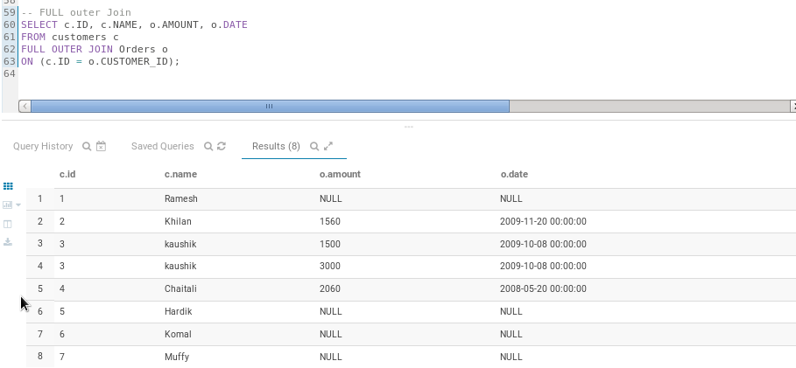
Step 4: Analytic Functions
- RANK()
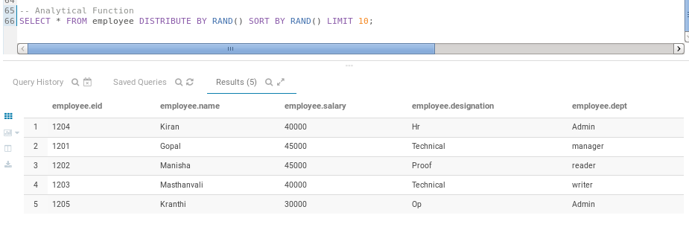

- DENSE_RANK ()
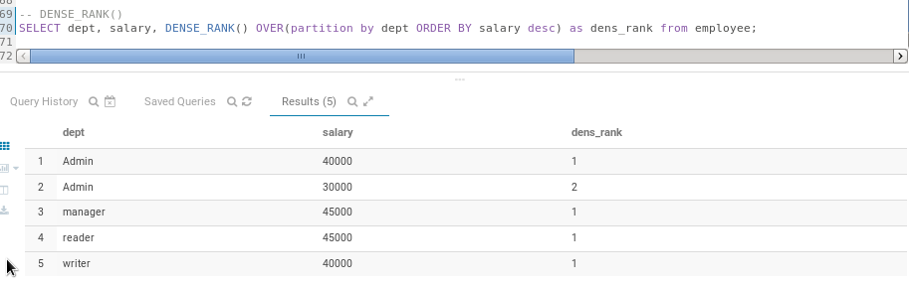
- ROW_NUMBER ()
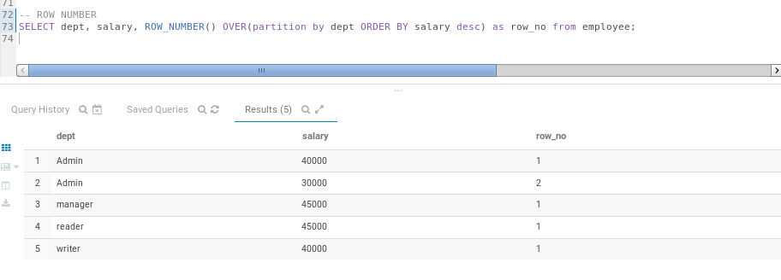
- CUME_DIST ()
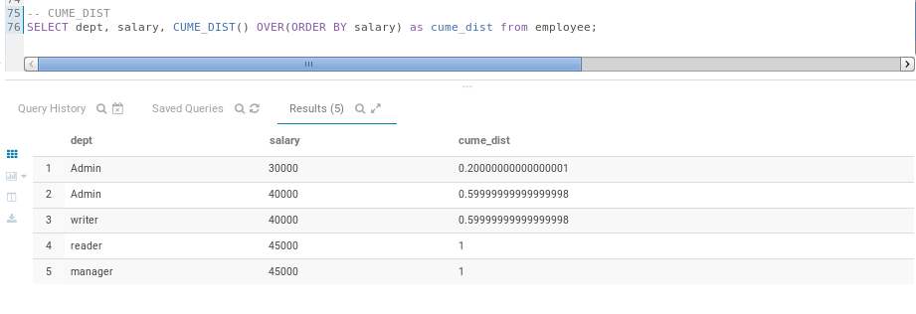

- PERCENT_RANK ()
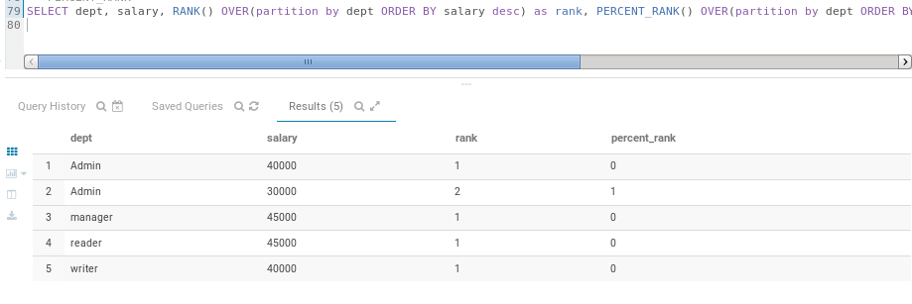
- NTILE ()
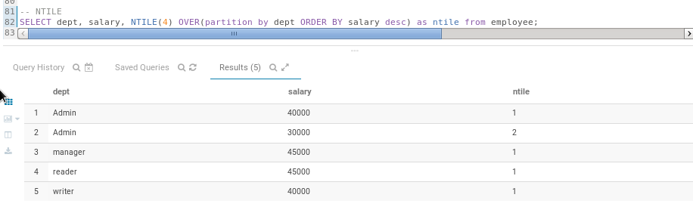
Exercise 4: Optimising Hive Queries
Step 1: Indexing
Step 2: Partitioning
- SET hive.exec.dynamic.partition=true;
- SET hive.exec.dynamic.partition.mode=nonstrict;
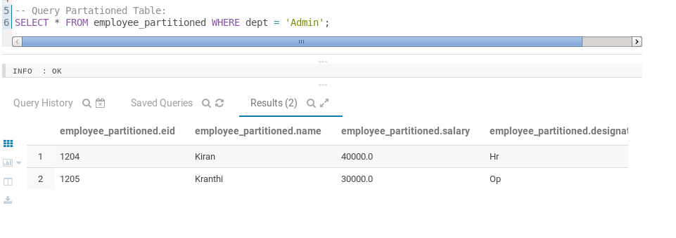

Step 3: Bucketing
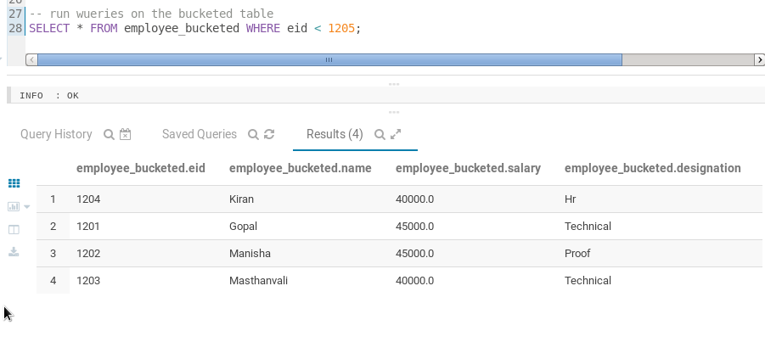
Step 4: Combining Partitioning and Bucketing
Q. Compare Query Performance:
# Run similar queries on non-partitioned, partitioned, and bucketed tables to analyse the differences.
- Based on my observation, non-partition table is the slowest because it scans the entire table data for every filter operation (e.g. WHERE statement) which slow down the performance. As for the partition, it divides table into smaller parts based on the categorical column value. In our case, we use filter condition (WHERE) with department, and it fetches the information based on departments. This approach is more efficient, reducing the amount of data scanned, and skips the partition which are not relevant and improve the query performance. On the other hand, bucketing sub-divides the data within each partition into fixed-size clusters. In our case, we use partition based on department and clustered by employee id. I think it is more based on size or numeric function or more logical rather than categorical column and because of that query performance is more efficient. Overall, partition and bucketing are optimized way of improving query performance. However, we must choose each of them based on the requirements.

